**Aim**

To implement a **Map Coloring CSP** in Python where each region (e.g., a state or country) is assigned a color such that no two adjacent regions have the same color.

**Algorithm**

1. **Define Variables**: Each region to be colored.
2. **Define Domains**: Set of available colors for each region.
3. **Define Constraints**: Neighboring regions must not share the same color.
4. **Backtracking Search**:
   * Select unassigned region.
   * Assign a color from its domain that satisfies all constraints.
   * Recurse; if conflict arises, backtrack.

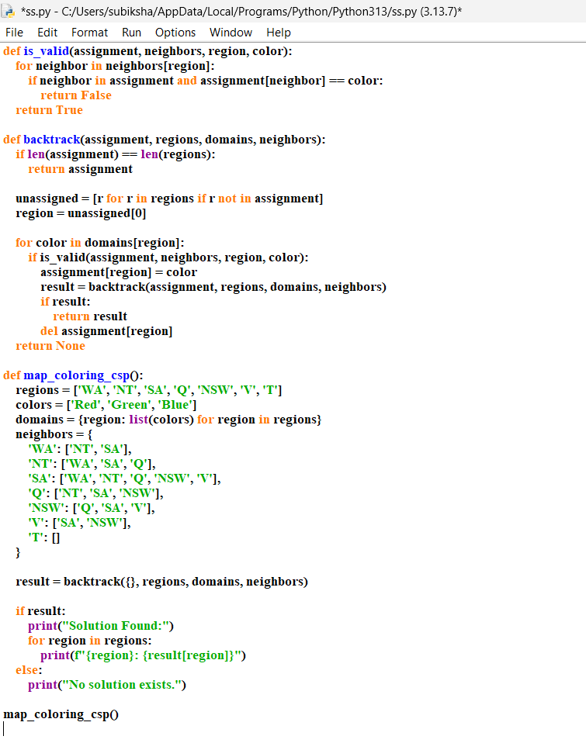

Result :

